Iteration 3
Penetration Testing Plan:

1. Introduction / Overview
This security plan outlines the approach taken to identify, address, and manage potential security threats throughout the development and deployment of our system. The goal is to ensure the confidentiality, integrity, and availability (CIA) of user data and system operations. As part of an agile development process, this document will evolve across iterations to reflect new risks, mitigations, and lessons learned. It serves not only as a technical guideline for the team but also as a communication tool for stakeholders concerned with the system’s safety and compliance.

2. About Our System
Our system is a web-based educational platform developed using the Flask framework, incorporating technologies such as Python, HTML, CSS, and JavaScript to deliver interactive content. The application is deployed via the Azure Web App Service, which integrates directly with GitHub for continuous deployment and version control. GitHub not only serves as our source repository but also ensures reliable backup of our development history. The backend relies on Azure’s MySQL flexible database to manage and store persistent user and system data. Additionally, third-party APIs are used to supplement dynamic content and enhance functionality. Users can access the platform from any device or operating system through a public Azure domain, with all interactions routed securely through Azure infrastructure to ensure stable, scalable, and responsive service delivery.
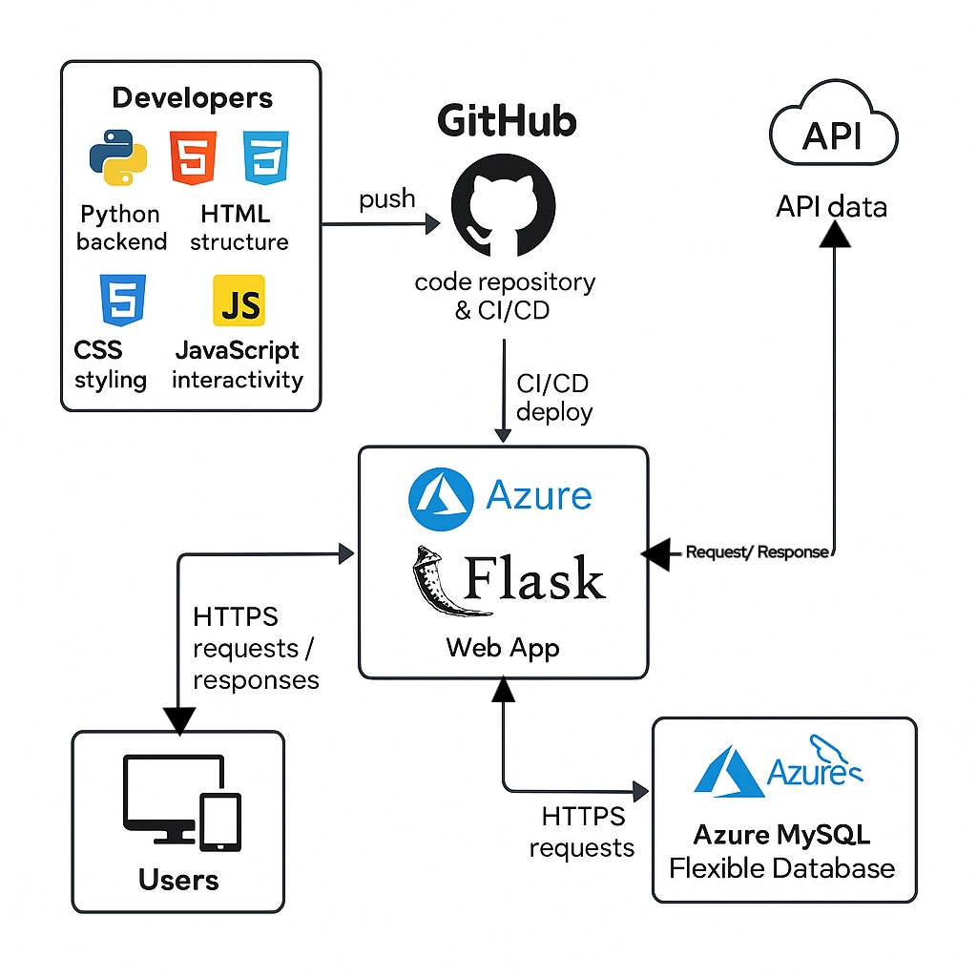

3. Security Awareness
Security plays a vital role in our project, especially as it targets parents and children—groups that may be more vulnerable to online threats. While our website does not collect user credentials or store personal data, it does utilize the browser's localStorage to save users' game progress. This limited data handling still requires attention to secure implementation, as insecure use of localStorage may expose the application to cross-site scripting (XSS) attacks.
To keep our project safe, we avoid using user-submitted data in any backend process, enforce secure content loading via HTTPS, and implement strict input handling within our front-end scripts. Without proper protection, potential threats such as code injection, unauthorized API access, or third-party script misuse could compromise the experience or trust of our users.
Although the security risks are relatively low due to the project’s limited data scope, a breach could still impact the integrity of the learning experience and reduce user trust. Since our system is aimed at educating users about online safety, any security flaw would also undermine the credibility of our message. Therefore, even with minimal data exposure, maintaining a secure front-end and a monitored backend is essential.

Table of Security Awareness
Risk name | Likehood | Imapact | Affected Components | Mitigation
ross-site scripting (XSS) | Medium | High | Storybook interface, homepage info sections, game text display | Sanitize all user-facing content and avoid using innerHTML where possible. Since some features (e.g., localStorage) rely on dynamic rendering, we also apply strict Content Security Policies (CSP).
Insecure usage of localStorage | High | Medium | Game progress storage, character status flags, unlocked paths | Use localStorage only for non-sensitive flags; validate and sanitize all stored values before use
Audio and media injection | Low | Medium | Background music system, story transitions, animation triggers | Host all files in static/, block mixed content, enforce HTTPS and correct MIME types
Uncontrolled API dependencies | Medium | High | APIs used in quizzes, statistics, future data-driven story paths | Use trusted APIs only, document all endpoints, add logging to monitor API responses
Misconfigured GitHub-Azure pipeline | Low | High | CI/CD pipeline, environment secrets, deployment automation | Restrict deployment to iteration2 branch, secure secrets in Azure App Settings, review YAML before push

5. Monitoring, Logging and Alerting
Monitoring and logging play a vital role in maintaining the integrity and availability of our web application. Although our system does not have user registration, authentication, or personal data collection features, it is still essential to monitor deployment activities, backend health, and database status to ensure reliability and early detection of potential security issues.
Our team utilizes Azure Web App’s built-in monitoring tools to oversee application uptime, HTTP traffic patterns, error rates, and deployment history. Azure App Service Diagnostics and Application Insights provide useful runtime logs, crash reports, and live metrics, allowing the team to track the health of the Flask backend and front-end delivery. Additionally, the Azure platform offers deployment logging and rollback tracking through its GitHub CI/CD integration. Any push to the iteration2 branch triggers deployment events that are logged and timestamped, helping identify the origin of potential issues quickly.
On the database side, Azure Database for MySQL (flexible server) includes automated query logging, connection attempt tracking, and resource usage monitoring (CPU, memory, I/O). Alerts can be configured to notify us if the database is experiencing unusual loads, suspicious query patterns, or frequent disconnects.
As the security lead, I (Tianyi Song) am currently responsible for reviewing these logs regularly and manually inspecting anomalies after each major update or during feedback-based revisions. Although our current architecture does not involve advanced SIEM (Security Information and Event Management) or SOAR (Security Orchestration, Automation, and Response) tools due to the project scale, we simulate basic detection by enabling Azure Monitor alerts for both the App Service and the database. These alerts are configured to flag unauthorized access attempts or traffic spikes, especially during off-hours.
We acknowledge the importance of continuous improvement and plan to scale up monitoring practices in the future, such as integrating open-source tools like Fail2ban for intrusion attempt logs, and implementing a lightweight custom logging system to capture specific client interactions (e.g., failed audio loads or card interaction issues) without violating user privacy.

6. Back-up, Incident Response & Disaster Recovery Plan
Back-up Plan:
Our system relies on Azure Web App and Azure MySQL Database. Therefore, we utilize Azure's automated backup service as our primary method. Azure performs daily backups of the database and retains them for 7 days, ensuring that we can restore important data when needed. At the code level, we use GitHub for version control, which automatically stores all changes and supports rollback. If a sponsor or third party needs to reproduce this process, they simply need to enable automated backups in the Azure Portal and ensure GitHub syncing is in place.
Incident Response Plan:
Potential incidents include website downtime, database connection failures, and third-party API interruptions. Upon detecting such issues, the designated project maintainer will receive real-time alerts via Azure's built-in notification system and use log files to diagnose the root cause. GitHub versioning allows for immediate rollback to a stable version in case of emergencies.
Disaster Recovery Plan:
If Azure experiences a major outage or service termination, we will immediately adopt the following steps:
- Redeploy the project using the GitHub codebase on an alternative cloud platform such as AWS or Google Cloud;
- Restore data from a manually exported MySQL backup file to a new environment;
- Use locally stored .env configuration files to replicate environment variables and secrets;
Our goal is to recover and deploy a minimal viable version of the system within 24 hours to minimize disruption to users.

7. Ethical, Privacy & Legal Concerns
Our platform does not collect any personally identifiable information (PII) and does not include user registration or login functions. Therefore, the privacy risk is relatively low. However, we still address several important concerns:
Use of Data:
We use the browser's local storage (LocalStorage) to save user progress within the game. This data is stored client-side only and never transmitted to the server, thereby improving user experience while maintaining privacy.
Processing of Data:
Since no backend user data is processed, the system avoids risks commonly associated with server-side data handling. However, we still conduct regular code reviews to ensure LocalStorage is not misused—for example, storing sensitive information or being accessed by unauthorized scripts.
Publishing of Data:
All content, including storylines and visuals, is created by our development team. There is no user-generated content (UGC) involved, so there is no risk of publishing private or unauthorized user data.
Legal Compliance (e.g., GDPR):
Although our platform primarily targets users in Australia, we still align with key GDPR principles such as data minimization and purpose limitation. We avoid collecting identifiable data, ensure anonymous browsing, and do not use cookies or tracking technologies unless strictly necessary.

